Shell Script Utilities Runbook

Author: Deepak Kumar Jha
Employee ID: 11749607
Objective: Create reusable Unix shell scripts for common operational tasks and document them in a detailed runbook.
Repository: https://github.com/deeepakjha475-sys/pip-shell-scripts

1. Disk Usage Monitoring Script
Script Name - disk_check.sh
Purpose
This script displays the current disk usage information of all available file systems. It helps administrators identify disk space consumption and monitor storage utilization.
Execution Steps
- Open Git Bash.
- Navigate to the script directory.
cd /c/PIP/ShellScripts
- Execute the script.
sh disk_check.sh
Screenshot
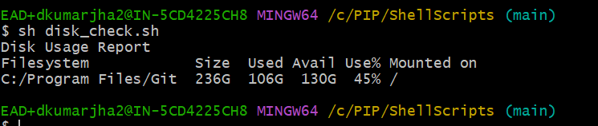
Troubleshooting
Issue | Resolution
Script not executing | Verify Git Bash is installed
Command not found | Ensure script is executed from Git Bash
No output displayed | Verify df command is available

2. Process Health Check Script
Script Name - process_check.sh
Purpose
This script checks whether a specific process is currently running on the system.
Execution Steps
- Open Notepad.
- Open Git Bash.
- Navigate to script directory.
cd /c/PIP/ShellScripts
- Execute script.
sh process_check.sh
Screenshot
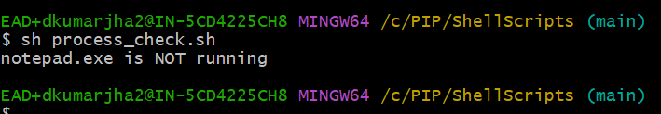
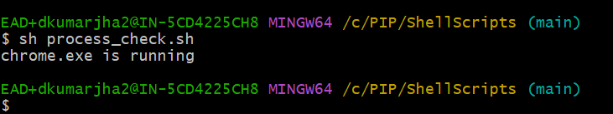
Troubleshooting
Issue | Resolution
Process not detected | Verify application is running
Incorrect output | Verify process name in script
grep error | Ensure Git Bash is used

3. Log Cleanup Script
Script Name - log_cleanup.sh
Purpose
This script identifies log files older than 7 days. It can help administrators locate old log files for cleanup and maintenance activities.
Execution Steps
- Open Git Bash.
- Navigate to script directory.
cd /c/PIP/ShellScripts
- Execute script.
sh log_cleanup.sh
Screenshot
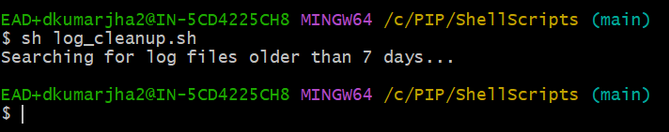
Troubleshooting
Issue | Resolution
No files displayed | No log files older than 7 days exist
find command error | Verify Git Bash installation
Unexpected results | Verify file timestamps

4. Error Log Monitoring Script
Script Name - error_monitor.sh
Purpose
This script scans a log file and extracts all entries containing the keyword "ERROR". It helps identify failures and issues from application logs.

Execution Steps
- Ensure application.log exists.
- Open Git Bash.
- Navigate to script directory.
cd /c/PIP/ShellScripts
- Execute script.
sh error_monitor.sh
Screenshot
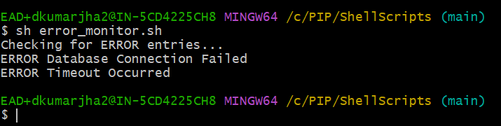
Troubleshooting
Issue | Resolution
File not found | Verify application.log exists
No ERROR records displayed | Verify log contains ERROR entries
grep command error | Use Git Bash

Repository Information
Git Commands Used
Initialize Repository
git init
Add Files
git add .
Commit Changes
git commit -m "Added shell utility scripts"
Push to GitHub
git push
GitHub Repository Screenshot
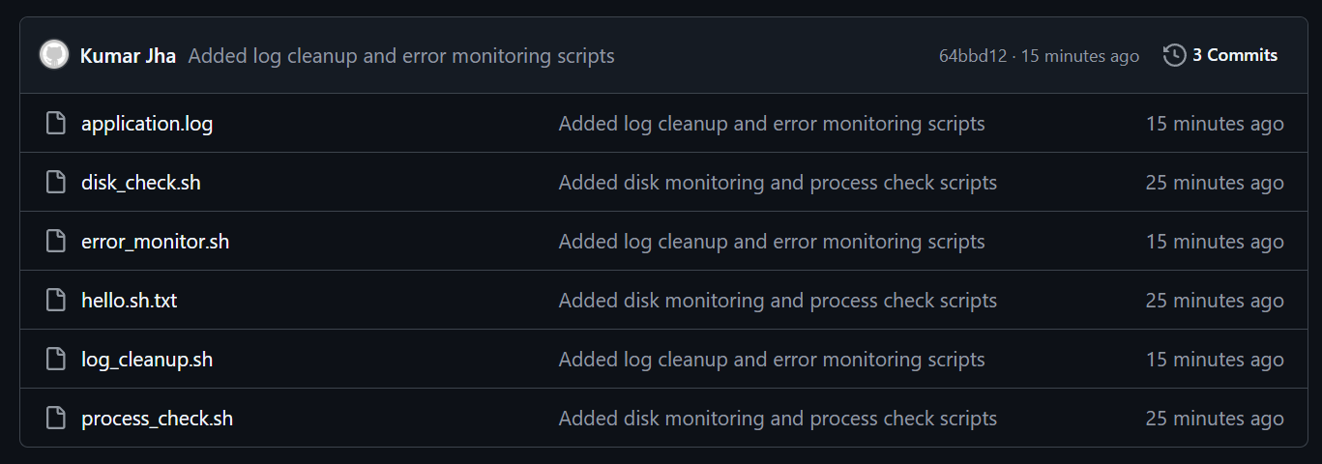
Conclusion
The following operational shell scripts were successfully developed, tested, and version-controlled using Git and GitHub:
- Disk Usage Monitoring Script
- Process Health Check Script
- Log Cleanup Script
- Error Log Monitoring Script
All scripts were executed successfully using Git Bash, and source code has been maintained in a GitHub repository for version control and future enhancements.

